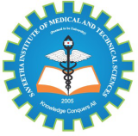
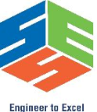
SIMATS ENGINEERING

Saveetha Institute of Medical and Technical Sciences
Chennai- 602105

Student Name: K. Ragavi Reg. No.: 192524364
Course Code: CSA0309 Slot: B
Course Name: Data Structures
Course Faculty: Dr. Uma Priyadarsini P.S
Project Title: Smart Student Skill Exchange Platform Using Graphs And Hash Tables
Module 3: Student Skill Network Using Graphs
Module Photographs: (3 photographs –Module Photo, Individual student contribution module work in the project and presentation image)
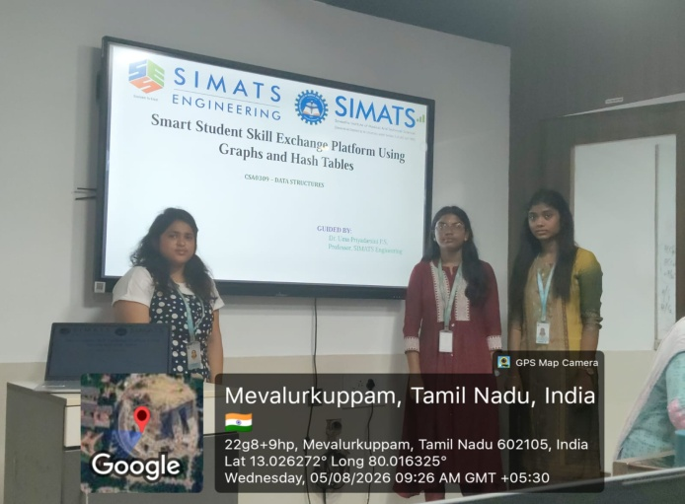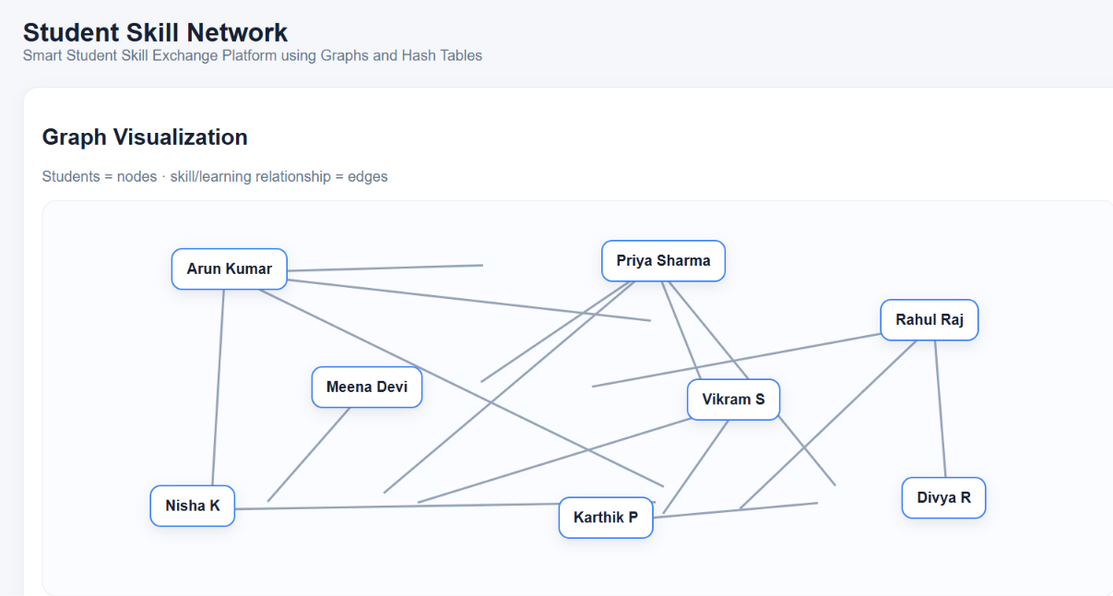
Project description: The Smart Student Skill Exchange Platform Using Graphs and Hash Tables is a data-structure-based platform developed to provide an efficient way for students to discover, share, and exchange skills with other students. In a college environment, students possess different technical and non-technical skills, but they may not always know who has a particular skill or who can help them learn it. This project solves this problem by organizing student information and skills in a structured manner using Hash Tables and Graphs. The Hash Table is used to store student details, skill information, and other relevant data, allowing quick insertion, searching, and retrieval of student records. The Graph data structure is used to represent relationships between students based on their skills. Each student is represented as a node, while connections between students represent common, complementary, or exchangeable skills. The system analyzes these connections to identify suitable skill partners and recommend students who can teach, learn, or collaborate with each other.

Student Signature Guide Signature

